Crocodile Stitch Scarf

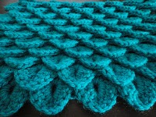
Medium: Crochet

Tools: You can use whatever yarn/hook combination you want. For this swatch I used an "I" hook, and worsted weight yarn, more specifically, "I love this yarn!" bought at my local Hobby Lobby.

Gauge: Whatever you want! :)

Abbreviations: ch - chain, DC - double crochet

Create slip knot. Chain in increments of 3 until you have a chain as long as you want for what you are making.
* For the scarf I made above, I chained 18.
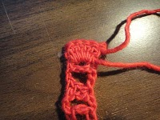

DC in 3rd chain from hook.
*Ch 2, Skip 2 ch, 2 DC* until the end of the chain.

Ch 1. Without turning work over, turn your work 90 degrees.

5 DC in first DC

Ch 1.

5 DC in second DC. This is your first shell/scallop/scale.

Skip next set of 2 DC's. Create Scale pattern in the 3rd set of 2 DC's.

Skip next set of 2 DC's. Create Scale pattern in the 5th set of 2 DC's.

Continue to the end of the row.

Ch 2, turn work over.

2 DC into center of the last Scale you crocheted. Ch 2.

2 DC between the last 2 Scales you crocheted. Ch 2.

Continue to the end of the row.

Ch 1. Turn work over.

Crochet the Scale pattern into the first set of 2 DC's. Skip 2nd set of DC's, crochet the Scale pattern into the 3rd set of DC's and continue to the end of the row.

Make this pattern however long you want, in this case, into a neck warmer or a scarf.

Enjoy!

