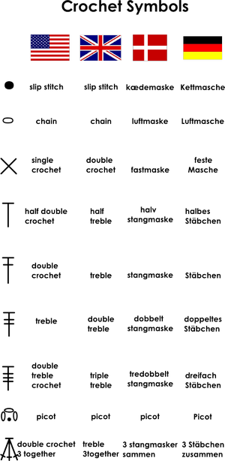

Getting Hooked on Crocheting
Your crochet hook is the single most important tool you use when crocheting. To understand how it works, you need to know a bit about how it's made. This article explains, in detail, everything you need to know about hooks, such as why they're shaped the way they are and the function of each distinct part.

The anatomy of a crochet hook
Even though a crochet hook appears to be nothing more than a straight stick with a hook on one end, you notice that it has five distinct and necessary parts, as Figure 1 shows.
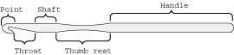
Figure 1: Identifying the five parts of a crochet hook.
Each part of the hook has been designed to perform a specific function.
- Point: This part of the hook is inserted into previously made stitches. It must be sharp enough to slide easily through the stitches, yet blunt enough so that it doesn't split the yarn or stab your finger.
- Throat: The open part underneath the point where the hook catches the yarn must be large enough to hold the yarn size that you're working with but small enough to prevent the previous loop from sliding off.
- Shaft: The shaft holds the loops that you're working with, and for the most part, determines the size of your stitches.
- Thumb rest: The flat part of the hook located on the shaft, the thumb rest, should be sandwiched between your thumb and middle finger when you hold the hook, enabling you to easily rotate the hook to the correct position to perform each stitch. Without the thumb rest, the hook can easily twist in the wrong direction, and you'll find yourself gripping the hook too tightly — leaving you with hooker’s cramp!
- Handle: The remaining length of the hook below the thumb rest completes the hook; this part is called the handle. Although you don't actually hold the hook by the handle, achieving the proper balance when crocheting is a necessity.
Many different companies manufacture hooks, and each company produces hooks with slightly different shapes. Some hooks have sharp points, while others have more rounded points. Some hooks have distinct flat, cutout throats, while others have smoother, rounded throats. Nowadays, most of the standard size and steel hooks have thumb rests; although the largest of the standard hooks don't. Take some time to experiment with a couple different brands of crochet hooks to find the one that you're most comfortable working with. You'll be glad that you did.

Crochet hooks: Choosing your weapon
Crochet hooks are made in a wide range of sizes and materials, but when you go to choose a hook, don't be overwhelmed by the seemingly endless choices.
- Standard hooks are most often made of aluminium or plastic (and sometimes wood) and are normally used when working with yarn. They measure about 6 inches in length and vary in thickness from 2.5 mm to 19 mm.
- Steel hooks, which are the smallest of all crochet hooks, are used for crocheting with thread and fine yarns. They're made of well, you know, steel, and measure about 5 inches in length and run from .75 mm to 3.5 mm wide.
Due to the nature of crochet, each stitch is worked until only one loop remains on the hook. Space isn't needed to hold many loops (the exceptions being the Afghan stitch and double-ended crochet). Therefore, the hooks can be made to a convenient length.
Hook sizes are denoted using three different systems, U.S. (American), Continental (metric), and U.K. (English), but don't let that fool you. They're quite often labelled with both the U.S. letter-number designation as well as the numeric metric designation. The size of the crochet hook refers to the thickness of the hook, which in turn determines the size of the stitches created. For standard hooks, using the U.S. or metric system, the higher the number or farther the letter is in the alphabet, such as P or Q, the larger the hook. For steel hooks, which use only a number designation, the opposite holds true. The higher the number, the smaller the hook.
When shopping for hooks, don't be afraid to splurge. Hooks are inexpensive, and having extras of the most common sizes doesn't hurt. Even after you've found the style of hook that you're comfortable with, hang on to any other hooks that you may have collected. You never know when you won't be able to find where you put your favourite hook, and that spare one you don't like as well will do as a backup when you absolutely have to get started now!
If you opt to use plastic crochet hooks, keep in mind that with heavy use, they can bend or break. Try using aluminium hooks for the standard sizes, simply because they literally last forever, provided that they don't disappear.

The Essentials of Crocheting a Gauge Swatch
Crochet a gauge swatch (a sample) of your pattern to get a sense of the finished fabric. When you crochet a gauge swatch, you use the same pattern, yarn, and hook that you intend to use for your project.

How to Crochet a Gauge Swatch
Crochet a gauge swatch to keep stitches consistent and the size of your design on track. When you work crochet the gauge swatch, work the stitches according to the instructions in the pattern. Crochet patterns almost always recommend a gauge for you to follow. Look for it at the beginning of the pattern instructions.
The pattern designer determines the gauge by taking into account the recommended yarn and hook size, the type of stitches used in the pattern, and the desired result. Although garment patterns usually mention both a stitch and a row gauge, the stitch gauge is the most important one to match. The stitch gauge determines the width of each piece of the design, which, when you sew the front and back together, adds up to the finished bust/chest measurement.
A simple pattern that uses just one stitch, like a double crochet stitch, states the gauge as a certain number of stitches and rows per a given number of inches. However, some patterns have a set of several different stitches that repeats across the row. In this case, the pattern states the gauge as one entire stitch repeat per a given number of inches.
Crocheters tend to crochet tighter at the beginning and end of rows than in the body of their work. So if the gauge calls for 7 stitches = 2 inches and 8 rows = 2 inches, make your swatch at least 4 inches square. That way, you can measure in the centre of the swatch and get an accurate measurement of your normal pace. If you’re working a gauge that has a repeated set of stitches, you may need to make it bigger than 4 inches square.

How to Choose Yarn for Your Project
When choosing yarn, remember that yarns, garment shapes, and stitch patterns must work together for a successful knitting or crochet project. Choosing yarn can be hard when there are so many yarn selections available. Here are some points to keep in mind:
- Match the yarn to the stitch. The yarn you choose can either accentuate the effect you’re trying to create or camouflage it. As a general rule, the wilder the yarn, the simpler the sweater shape and pattern stitch should be. The plainer the yarn, the more texture and shaping details will show up.
Here are some guidelines:
  - Smooth-plied yarn in a solid colour: Use these yarns for cables and more complex stitch patterns. They give your stitches a crisp look, showcasing your effort. In general, plied and twisted yarns are sophisticated and classic. Single plies are rustic and relaxed.
  - Variegated and novelty yarns: Don’t knock yourself out with tricky stitch work if you’re using variegated or highly textured yarns. The stitches won’t show up, and all your stitch-making effort will be for naught. Simple stitches, such as stockinette and garter, are best with these yarns.
  - Cotton, silk, soy, bamboo, and other inelastic yarns: Look for patterns that don’t depend on ribbing for fit. Find patterns that hang straight to highlight the drape of these yarns.
- Substitute one yarn for another. If you don’t want to use or can’t find the yarn specified on a pattern, the safest option — at least until you’re experienced enough to take into account all the factors — is to talk to a sales associate in a specialty yarn shop.
When substituting yarn, consider the following:
  - Yardage: Be sure to pay attention to actual yardage listed on the label, not just number of grams or ounces.
  - Weight: The weights (thicknesses) should be the same. If the pattern you’ve chosen expects you to get 4 stitches and 6 rows to the inch and you substitute a yarn that gives you a different gauge, your sweater will turn out a different size than the one given in the pattern.
  - Fibber: Yarns of different fibres, even if they have the same gauge, will have different characteristics.
Be sure you know the characteristics of the yarn and are comfortable with the way these differences will affect the finished piece. Just because two yarns have the same gauge doesn’t mean that they can substitute for each other successfully in a given pattern. If the yarns have different characteristics — texture, drape, fibre, and colour — then the final garment will look and feel different from the one pictured in the pattern.

How to Read Crochet Abbreviations
Most crochet stitches appear as abbreviations to save space on the written instructions. For example, you’ll see the abbreviation dc instead of double crochet stitch throughout a pattern.
Crochet abbreviations don’t have periods after them in order to keep the instructions as clutter-free as possible. If you do come across a period that isn’t at the end of the sentence or action, it’s probably attached to an abbreviation that's easily confused with another word, such as in. meaning inches as opposed to in — the word.
Common Crochet Abbreviations
Abbreviation | Spelled-Out Term
approx | approximately
beg | begin(ning)
bet | between
blp | back loop only
BP | back post
CC | contrast colour
ch | chain
dc | double crochet
dec | decrease(s)(d)(ing)
dtr | double treble crochet
flp | front loop only
foll | follow(ing)
FP | front post
hdc | half double crochet
inc | increase(s)(d)(ing)
MC | main colour
pat | Pattern
rem | Remaining
rep | repeat
rib | Ribbing
RS | right side
sc | single crochet
sl st | slip stitch
st(s) | stitch(es)
tog | Together
tr | treble crochet
WS | wrong side
yo | yarn over hook
One notation that you see quite frequently in crocheting instructions is the hyphen. Instructions commonly use the hyphen when referring to a chain loop — the hyphen denotes the number of chains you work to create a particular loop. For example, a ch-5 loop is a loop made up of 5 chain stitches. Don’t confuse this instruction, however, with ch 5, which instructs you to make a chain of 5 chain stitches in a row.
Some patterns combine several basic stitches into a more complex stitch. For example, 5 double crochet stitches worked in the same stitch is called a shell because it resembles the shape of a clamshell. Besides having their own names, these special stitches may also have their own abbreviations.
Special stitches aren’t standardized and may have different definitions in each pattern that you encounter. For example, one pattern may define a shell as 5 double crochet stitches, but another pattern may define it as only 3 double crochet stitches. Before you begin, be sure to check the beginning of the pattern’s instructions for the definition of each special stitch.

How to Follow a Stitch Diagram in Crochet
Following a stitch diagram in crochet isn't that scary once you understand the symbols and abbreviations. When you read a crochet pattern, the stitch diagram shows only a few rows to avoid repetition and save space. You work it in identical rows consisting of repeated sets of crochet stitches. The pattern tells you how many rows to make to complete the piece.
Stitch diagram basics:
- When working in rows, the right side row number is placed on the right-hand side of the diagram, which means you work from the right side to the left side. On wrong side rows, the number is on the left-hand side, so you follow the diagram from left to right.
- When working in rounds, you read the diagram counterclockwise, without turning between rows unless the instructions specifically instruct you to do so.
- Left-handed crocheters go in reverse. Stitch diagrams are generally laid out from the right-handed crocheter’s point of view, but a left-handed crocheter can read them just as well if he or she reverses the direction of the pattern, and works from left to right instead of right to left. To work in rounds, a lefty still follows the pattern counterclockwise, but works the piece clockwise, thus reversing the direction of the pattern.

How to Start the Yarn on a Crochet Hook
Knowing how to start the yarn on a crochet hook is your first step to crocheting. To start the yarn on a crochet hook, you first wrap the yarn around your yarn hand and then create a slip knot on your hook.
1 Bring the yarn up between your little finger and ring finger.
Start the yarn from underneath your hand.

2 Wrap the yarn around your little finger.
Look — it's a ring made from yarn!
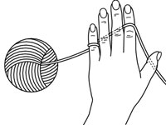
3 Draw the yarn under your ring finger and middle finger, then bring the yarn up to the top of your hand between your middle finger and forefinger.
Lay the yarn over your forefinger (or index finger or pointing finger).
4 Make a loop that looks somewhat like a pretzel.
Begin about 6 inches from the end of the yarn.
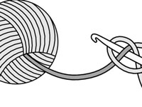
5 Insert your hook through the centre of the loop and draw the working end of the yarn through.
This step creates a slip knot.
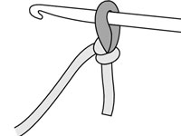
6 Pull gently on both ends of the yarn to tighten.
If pulling on the working end of the yarn doesn’t tighten your slip knot on the hook and yanking on the cut end does, you made your slip knot backwards. Simply remove the loop from the hook, tug on both ends to release the knot, and try again.
A starting slip knot should slide easily up and down the crochet hook's shaft, but shouldn’t be so loose that it slides off over the end of the hook. If it's too loose, gently pull on the working end of the yarn to snug it up. If your knot is too tight, tug on the loop to loosen it.
To keep the yarn in place, grasp the end of the yarn between your middle finger and thumb. By raising or lowering your forefinger, you can control the yarn tension. Practice wrapping and rewrapping the yarn around your yarn hand. If you ever feel that your working yarn is too loose or too tight, stop and rewrap to get the proper tension. This motion soon becomes an ingrained habit.

How to Crochet a Row
Going back and forth may not get you places in real life, but it sure does when you’re crocheting in rows. When you crochet rows, you need to turn your work, make your turning chain, and start back across the row.
With a starting row of 16 double crochet stitches, you can crochet a row of stitches:
- Turn your work to prepare for the next row.
- Chain 1 (ch 1; turning chain for double crochet).
- Insert your hook from front to back underneath the top two loops of the first stitch.
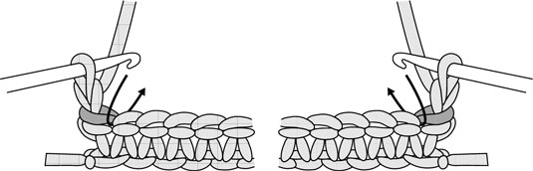
- Wrap the yarn over the hook (yo).
- Draw your yarn through the stitch.
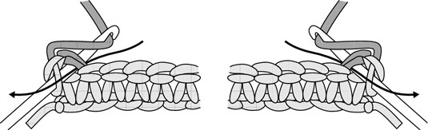
- Wrap the yarn over the hook.
- Draw your yarn through the two loops on the hook.
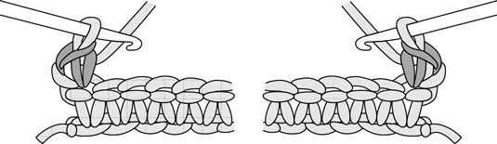
Now you have one double crochet in the second row completed, and one loop remains on the hook.
- Work one double crochet stitch in each double crochet stitch from the previous row all the way to the end.
Make sure to count your stitches when you get to the end of the row. You should have exactly the same number of stitches in the second row as in the first.
Working a practice crochet swatch helps you figure out new stitches and start making them like a pro. Use worsted-weight yarn (it’s easiest to work with) and a size H-8 hook to make a foundation chain approximately 4 inches long and then chain 1 for your turning chain. Work as many rows of double crochet as you need to until you feel comfortable with the new stitch.
Some patterns like to change things up and may tell you to insert your hook in a different place in the previous row. But if no specific instructions are given, always work the stitches in each subsequent row under the top two loops of the stitch in the previous row. This is the best way to create a smooth, even fabric.

How to Turn Crochet Work
To turn crochet work around so that you can start a new row of stitches, keep the last loop on your crochet hook and simply take the completed work, which should be positioned under your hook hand, and turn it toward you until the work is positioned under your yarn hand.
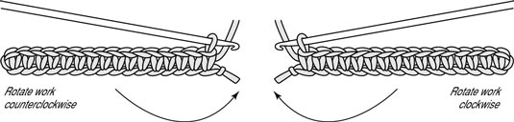
By using this technique, you hold the work between the middle finger and thumb of your yarn hand, your yarn is positioned behind your work, and the hook is in place to work the beginning stitches of the next row.
Keep in mind that each time you turn your work to crochet back across the previous row, a different side of the piece will be facing you. If the first row is designated as the right/front side of the piece, then when you turn to work the second row, the wrong/back side is facing you. The third row again has the right/front side facing you, and so on.

How to Fasten Off Yarn in Crochet
When you get to the end of your crochet design and you’ll need to fasten off the yarn. Fastening off crochet is a fancy way to say “cut the yarn and secure it.” You also need to fasten off one colour to join a new colour if you’re working with different colour yarns.
1 Cut the yarn about 6 inches from the hook.
You weave the yarn end into the fabric to secure it.
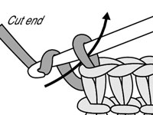
2 Using your hook, draw the cut end of the yarn through the last remaining loop on your hook.
This step actually fastens off the yarn.
3 Pull gently on the tail of yarn to snug up the end.
This action keeps your work from coming apart without having to make large unsightly knots.
4 Thread the remaining yarn tail onto a yarn needle.
You need the yarn needle to weave the yarn into the fabric.
5 Weave the 6-inch tail of yarn up and down through 3 or 4 stitches — kind of in a zigzag pattern.
Be careful not to split the yarn of the stitches.
6 Go back the way you came, weaving the end backwards through those same few stitches.
This step makes the end really secure.
7 Cut the yarn about 1/4 inch from the fabric and gently pull the fabric.
The end disappears like magic, and your work is secure.

How to Measure a Gauge Swatch
In knitting and crochet, accuracy counts when measuring your gauge swatch. Before you measure your gauge swatch, wash and block it, if that's what you'd do for the completed project. Next, smooth out the swatch on a flat surface, like a blocking or ironing board. Pin down the edges of the gauge swatch if they’re curling in, and be careful not to stretch your swatch.
- For stitches, lay a ruler along a row of stitches and mark the beginning and end of 4 inches with pins.
If your second pin lands at half a stitch, don’t be tempted to stretch or slightly squish your fabric to make the 4 inches end on a whole stitch.
- Note the number of stitches in 4 inches.
Fractions and all!
- For rows, lay your ruler along a vertical line of stitches.
Align the bottom of the ruler with the bottom of a stitch or row.
- Put a pin in to show where the first stitch begins, then place another pin 4 inches up.
This step marks off the area that will represent your gauge.
- Count the stitches between the pins and note the number of rows.
Check to see if your 4-inch gauge matches the one in the pattern.
If your gauge swatch doesn’t match the one specified in the pattern you want to use and you want your project to come out the same size as the pattern measures, change the needle size you’re working on and make another swatch. If your first swatch is smaller than specified, then use larger needles. If your swatch is larger than specified, use smaller needles.

