Granny Squares – Crochet a Shoulder Tote
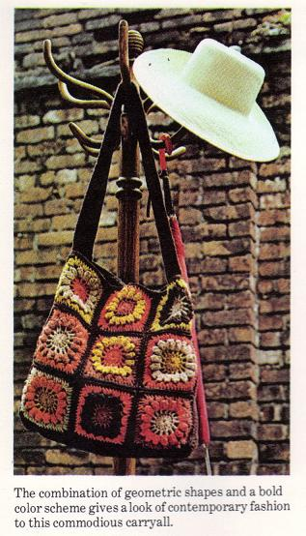
Earthy tones of brown, gold and orange were used for the soft-sided shoulder tote bag. Its 15-by-15-by-2 1/2 inch dimensions give it a generous capacity. Each side is made of nine 5-inch squares; the band joining the sides and the handle is made of a continuous strip of double crochet.
Size: 15 by 15 by 2 1/2 inches deep.
Handle portion is 34 1/2 inches long.
Materials: 4-ply knitting worsted (4-ounce skein), 1 each of orange, beige, gold, and rust, 2 each of dark brown.
Crochet hook size G or size needed to obtain gauge.
No. 18 tapestry needle.
2 1/4 yards of 2 1/4-inch-wide brown grosgrain ribbon, 1 yard of 1-inch-wide brown grosgrain ribbon. 1/2 yard of 45-inch-wide heavy-weight brown lining,
brown thread,
sewing needle.
Gauge: Squares are 5 by 5 inches.
Handle gauge is 4 st= 1 inch, 2 rows of dc=l inch.
Squares: Follow crochet directions for popcorn afghan squares, alternating colors for rnds 1, 2, 3 and 4. Use dark brown for rnd 5 only.
Make 18 squares.
Joining: Join squares for sides, 3 squares by 3 squares. Alternate squares to vary colors. From right side, along what will be upper edge of tote, join dark brown yarn in center sc of corner, ch 1. Work sc in each sc of square and sc in seam between squares. Fasten off yarn in center sc of lef corner. Block sides of tote after squares are joined.
The handle/band: Join dark brown yarn at center of middle square at lower edge, ch 1. Work 1 sc in each sc of square and 1 sc in seam between squares. Do not increase at corner. At upper edge of
side, work 2 sc in side of sc edging to secure it. Then ch 134. Join chain to other side of upper edge with 2 sc in side of sc edging. Work 1 sc along side and bottom of tote, joining to first ch-1 with
sl st. *Ch 3, work 1 dc in each sc and ch around entire bag and handle. Join to top of ch-3 with sl st. Repeat from * 3 more times. Ch 1 and work final row of sc in each dc. Join with sl st; fasten off.
The under handle: With dark brown, ch 140. Insert hook in 4th ch from hook and work 1 dc in each ch. *At end, ch 3, turn, work 1 row dc. Repeat from * twice more. Ch 1, turn and work final row of sc. Fasten off.
Assembling tote: Each side of the tote bag is made of nine squares sewn together to make a larger square. The 2-inch-wide band between the sides and the 2-inch-wide handle, called a handle/band, is one continuous strip of double crochet that is crocheted directly on to one of the granny-square sides (see directions for the handle/band above). Working on the inside of the tote, sew second granny-square side to outside of handle/band (Figure E), along sides and bottom.
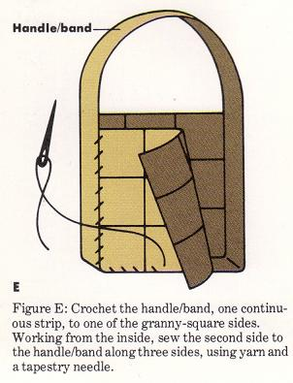
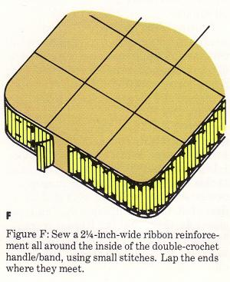
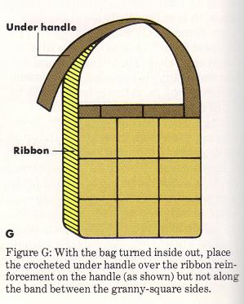
The handle/band is reinforced with grosgrain ribbon. With the tote inside out and starting at center bottom, pin 2 1/4-inch-wide ribbon to the inside of the entire handle/band. Lap ends and secure ribbon in place with catch stitches (Figure F). To finish the handle, the crocheted under handle (see directions above) is placed over the grosgrain ribbon along the handle (but not along the band between granny-square sides) (Figure G). The three layers of the handle, two layers of double crochet with a ribbon reinforcement between them, must be crocheted together.
To do this, turn tote right side out. From right side of upper handle, join dark brown yarn to top loop of upper handle above sides and top loop of 2nd stitch of the under handle. Ch 1 and work 1 row of sc through one loop of each handle section (Figure H). Fasten off at other granny-square side. Join other edge of crocheted handles in same manner, sandwiching the ribbon between handle sections. Lightly steam the under handle to shrink any fullness. Let dry before attaching lining.
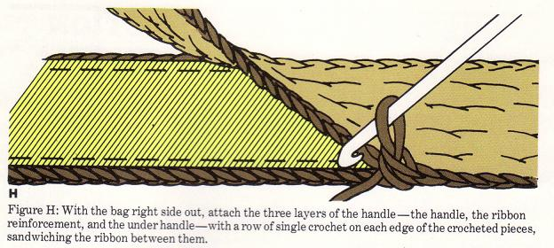
Lining: Cut two pieces of lining each 18 1/2 inches wide by 17 1/2 inches long. One-half inch seams are allowed. With right sides together, machine stitch along one side of lining, across bottom, and along other side. Press seams open. Fold into triangle at corner and stitch across corner 1 1/8 inch from end. Trim corner to 1/2 inch (Figure I).
Press crease along either side of lining from one end of stitching to the other (Figure J). Turn under 1/2 inch at top of lining and press. Stitch 1-inch-wide ribbon just inside pressed edge of lining (Figure K), and overlap edges of ribbon where they meet. Insert lining into bag, aligning side seam of lining with center of bands and hand sew in place just below edge along sides. Secure lining to lower edge of tote at corners with several small stitches.
