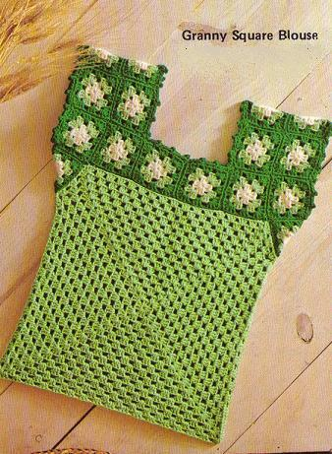
Instructions are for Medium size.
Materials - 4ply worsted weight yarn – 8 ounces main color, 4 ounces each color A and B
crochet hook Size I or size to give gauge
Gauge: 2 rnds to 1″; Large square is 17″, Small square is 3″
Finished Measurement: Bust 34″
LARGE SQUARE (Make 2): With MC, ch 3. Join with a sl st to first ch to form a ring.
Rnd 1: Ch 3 (counts as first dc), 2 dc in ring, ch 1, [3 dc in ring, ch 1 ] 3 times, join with a sl st to top of ch-3.
Rnd 2: Ch 3, 2 dc in ch-1 sp to right of joining, ch 1, 3 dc in same sp, ch 1, [in next ch-1 sp work 3 dc, ch 1, 3 dc, ch 1 ] 3 times. Join with a sl st to top of ch-3 (all rnds are joined in this way and worked from right side).
Rnd 3: Ch 3, 2 dc in ch-1 sp to right of joining, ch 1, [in next ch-1 sp work 3 dc, ch 1, 3 dc (corner), ch 1, 3 dc in next ch 1 sp, ch 1 ] 3 times, work corner, ch 1, join. There are 4 corners with one 3-dc grp between corners.
Rnd 4: Work as Rnd 3, having two 3-dc grps between corners. Continue rnds with 1 more 3-dc grp between corners in every rnd until there are 15 grps between corners. Join and fasten off.
SMALL SQUARE (Make 26 for Yoke): Using color sequence of A, MC & B, work same as Rnd 1-3 of Granny Square Afghan (click here)
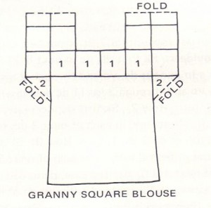
To Join Yoke Squares: Follow diagram for placement of squares. Hold right side of 2 squares tog. Using B overcast through top lps only, matching sts. Sew in any loose ends neatly on wrong side.
To Join Yoke to Front:
With right sides tog, pin lower edge of #1 squares (see diagram) to top edge of large square. Hold front facing you, yoke at back. With crochet hook join B in ch-1 of right hand corner of front and yoke square. Through top lps only work sl st loosely through both pieces (do not draw work), skipping each ch-1 of front square (to gather front to fit yoke), end in corner ch-1 at left edge. Fasten off.
Join yoke to back in same way.
Fold # 2 squares and overcast to front and back as shown in diagram. Overcast underarm seams.
Picot Edge on Neck:
Join B at seam of 2 squares at center back, through back lps, sc in each of next 3 dc, sc in back lp of next ch-1 sp, ch 3, insert hook in top of last sc and under strand at left side of same sc, work sl st (picot), sc in back lp of each dc to joining, sc and picot at joining. Continue in this way to work sc in each dc, sc and picot in each ch-1 sp and at joining of squares to corner of neck, sc and picot at corner, continue around neck in this way, ending sc and picot in last st. Join with a sl st to first sc. Fasten off.
Beg at underarm, work picot edge around armholes in same way.

