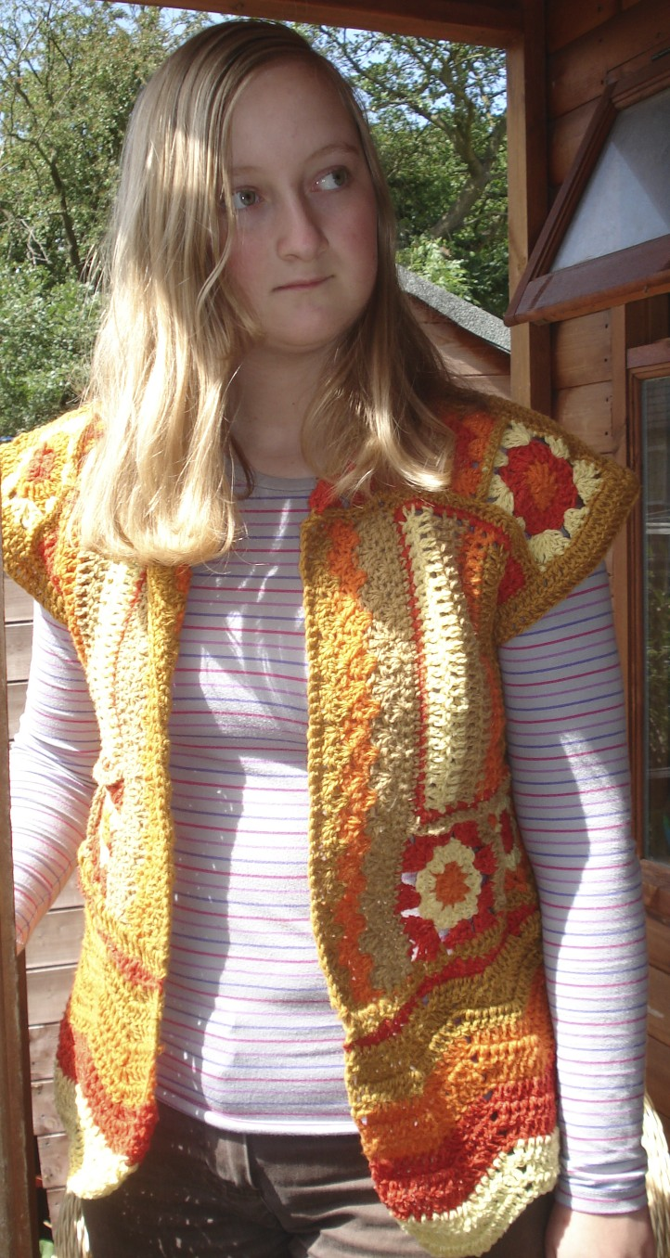
Granny Square Waistcoat – Pattern by Lisa Hafey

Difficulty: Intermediate

Materials: yarn – DK weight yarn, 75% larmbswool, 25% silk, sourced from http://www.kingcraig.com/ in colours (A) mustard, (B) primrose yellow, (C) tan, (D) lobster fleck red, and (E) bright orange. Approximately 4 balls each.

Hook – UK size 4.00mm.

Available size – fits approximately UK size 14. Can be adjusted to fit with additional/less rows if required.

Stitches – slip st (sl st), chain (ch), double crochet (dc), half treble crochet (htr), treble crochet (tr), double treble crochet (dtr), triple treble crochet (ttr).

Instructions:

Granny Squares (make 30)

Note: Use all colours, with 3 rows to each granny square – be creative!

Row 1 – Using 1st colour of your choice, Ch 2. Work 10 tr into 2nd chain from hook. Join circle with sl st. Change to 2nd colour of your choice, joining anywhere.
Row 2 – Ch 2, count as 1st tr. Work a further 2 tr, ch 1. 3tr ch 1. Continue right around circle. Change to 3rd colour of your choice, joining anywhere.
Row 3 – Ch 2, count as 1st tr. Work a further 3 tr. Ch 2. Work 3 tr. Ch 1. This becomes first corner. Work 3tr, ch 1. Work 2nd corner. Continue in this fashion. Fasten off, weave in ends.

Join 20 granny squares for the back (5 columns wide, 4 rows long), using colour A, in htr. The joins show, so this is the right side.

Stripe Strip (make 2)

Row 1 – With colour of choice, ch 32. Tr in 3rd ch from hook and each rem ch across, turn.

Row 2 – ch 2 (does not count as st), tr in each tr across (30 tr). Change to 2nd colour.

Work strips in each colour, 2 rows each. Edge finished stripe strip with dc in third colour.

Join 2 granny squares to each other, using htr as for back (joins showing). Join 2 square strip to one narrow sides of each stripe strip. This makes a strip of fabric comprising a stripe strip and 2 granny squares. Edge this section using mustard.
Shell Strip

Left front: Lay strip with granny square section to left. Now work the shell strip.

Row 1 - Join colour of choice to the upper right corner of the long edge of the strip. Ch 1, then dc evenly along length of strip, working one dc in each motif st and 1 dc in each seam between motifs. The final number of dc sts on this row needs to be a multiple of 4, plus 3 extra. After row of dc is complete, turn.

Row 2 – Ch 3 (counts as tr), tr in same st, sk next st, dc in next st, *sk next st, 3 tr in next st, sk next st, dc in next st; repeat from * across, turn.

Repeat Row 2, changing colours as desired, using 3 colours total.

Final row – Ch 1, then dc in each st along row, finish, weaving inends.

Edge entire section in mustard.

Join 3 granny squares (using previous method), attach to top of strip.

Right front: Work as for left front, only with granny square section to right.

Chevron Strip

(Back) Row 1 – Join colour of choice to bottom of back. Ch 1, dc in same st, *dc in next st, htr in next 2 st, tr in next 2 st, dtr in next 2st, ttr in next 2 st, dtr in next 2 st, tr in next 2 st, htr in next 2 st, dc in next st; repeat from * across, dc in last st, finish.

Row 2 – Join new colour, ch 3 (counts as tr), sk st under ch and next st, *tr next 6 st, 3 tr in next st, tr in next 6 st, sk 2; repeat from * across, ending last rep by sk 1 rather than 2, tr in last st. Repeat row 2 once more, change colour.

Work 3 x row 2, change colour. Repeat – 4 colours in total.

Work same for left and right fronts.

Starting from top of second last colour (ie. middle of chevron rows), join left and right fronts to granny square back, using tr. Space evenly, stitching together until half way up granny squares for back (ie. between rows 2 and 3). Break off. Join top of left front to back, using same tr method as before, leaving free the edge square (on the front), and the centre square (on the back). Do the same for right front.

Shape armholes – Tr evenly around armholes, using mustard.

Weave in all ends.

